

FACULTY OF TECHNOLOGY AND ENGINEERING
DEVANG PATEL INSTITUTE OF ADVANCE TECHNOLOGY AND RESEARCH
DEPARTMENT OF INFORMATION TECHNOLOGY

A.Y. 2026-27 [SEMESTER 3]

LAB MANUAL

CEUE203: Object Oriented Programming


Practical 7

Annotations and reflection
Problem Statement:
1. Form validator: inspect runtime @NotBlank and @MaxLength annotations and report field errors.
2. Mini test runner: find and invoke only methods annotated with @Run.
3. Column mapper: map CSV-like header and row values to fields using @Column.
Expected Output: The sample programs demonstrate the required behavior; see the captured console output below.

Solution:

ColumnMapperDemo.java
import java.lang.annotation.ElementType;
import java.lang.annotation.Retention;
import java.lang.annotation.RetentionPolicy;
import java.lang.annotation.Target;
import java.lang.reflect.Field;
@Retention(RetentionPolicy.RUNTIME)
@Target(ElementType.FIELD)
@interface Column {
String value();
}
final class ImportedUser {
@Column("name") String name;
@Column("email") String email;
@Override public String toString() { return name + " <" + email + ">"; }
}
public class ColumnMapperDemo {
static ImportedUser map(String[] header, String[] row) throws ReflectiveOperationException {
if (header.length != row.length) throw new IllegalArgumentException("Column count mismatch.");
ImportedUser user = new ImportedUser();
for (Field field : ImportedUser.class.getDeclaredFields()) {
Column column = field.getAnnotation(Column.class);
for (int i = 0; i < header.length; i++) {
if (header[i].equals(column.value())) {
field.set(user, row[i]);
break;
}
}
if (field.get(user) == null) {
throw new IllegalArgumentException("Missing column: " + column.value());
}
}
return user;
}
public static void main(String[] args) throws ReflectiveOperationException {
System.out.println(map(new String[]{"email", "name"},
new String[]{"riya@example.com", "Riya"}));
}
}

FormValidatorDemo.java
import java.lang.annotation.ElementType;
import java.lang.annotation.Retention;
import java.lang.annotation.RetentionPolicy;
import java.lang.annotation.Target;
import java.lang.reflect.Field;
import java.util.ArrayList;
import java.util.List;
@Retention(RetentionPolicy.RUNTIME)
@Target(ElementType.FIELD)
@interface NotBlank { }
@Retention(RetentionPolicy.RUNTIME)
@Target(ElementType.FIELD)
@interface MaxLength {
int value();
}
final class SignupForm {
@NotBlank @MaxLength(30) private final String name;
@NotBlank @MaxLength(60) private final String email;
SignupForm(String name, String email) {
this.name = name;
this.email = email;
}
}
public class FormValidatorDemo {
static List<String> validate(Object object) throws IllegalAccessException {
List<String> errors = new ArrayList<>();
for (Field field : object.getClass().getDeclaredFields()) {
field.setAccessible(true);
Object value = field.get(object);
String text = value == null ? "" : value.toString();
if (field.isAnnotationPresent(NotBlank.class) && text.isBlank()) {
errors.add(field.getName() + " must not be blank");
}
MaxLength maxLength = field.getAnnotation(MaxLength.class);
if (maxLength != null && text.length() > maxLength.value()) {
errors.add(field.getName() + " exceeds " + maxLength.value() + " characters");
}
}
return errors;
}
public static void main(String[] args) throws IllegalAccessException {
System.out.println(validate(new SignupForm("", "a".repeat(70))));
System.out.println(validate(new SignupForm("Riya", "riya@example.com")));
}
}

MiniTestRunner.java
import java.lang.annotation.ElementType;
import java.lang.annotation.Retention;
import java.lang.annotation.RetentionPolicy;
import java.lang.annotation.Target;
import java.lang.reflect.InvocationTargetException;
import java.lang.reflect.Method;
@Retention(RetentionPolicy.RUNTIME)
@Target(ElementType.METHOD)
@interface Run { }
final class SampleTests {
@Run void addition() { if (2 + 2 != 4) throw new AssertionError("addition"); }
@Run void text() { if (!"java".toUpperCase().equals("JAVA")) throw new AssertionError("text"); }
void ignored() { throw new AssertionError("unmarked method ran"); }
}
public class MiniTestRunner {
public static void main(String[] args) throws ReflectiveOperationException {
Object target = new SampleTests();
int count = 0;
for (Method method : target.getClass().getDeclaredMethods()) {
if (method.isAnnotationPresent(Run.class)) {
try {
method.invoke(target);
count++;
System.out.println("PASS: " + method.getName());
} catch (InvocationTargetException exception) {
throw new AssertionError("Test failed: " + method.getName(),
exception.getCause());
}
}
}
System.out.println("Tests run: " + count);
}
}

MiniBank Project Work:

MiniBank progress ? Practical 7
Completed: runtime @Id, @Positive, and @MaxLength metadata; Account fields are annotated, and AnnotationValidator reads annotated model metadata by reflection.
Single project location: Java Programs\Minibank

Progressive source excerpts:

Minibank/src/main/java/minibank/model/annotation/Id.java
package minibank.model.annotation;
import java.lang.annotation.ElementType;
import java.lang.annotation.Retention;
import java.lang.annotation.RetentionPolicy;
import java.lang.annotation.Target;
@Retention(RetentionPolicy.RUNTIME)
@Target(ElementType.FIELD)
public @interface Id { }

Minibank/src/main/java/minibank/model/annotation/Positive.java
package minibank.model.annotation;
import java.lang.annotation.ElementType;
import java.lang.annotation.Retention;
import java.lang.annotation.RetentionPolicy;
import java.lang.annotation.Target;
@Retention(RetentionPolicy.RUNTIME)
@Target(ElementType.FIELD)
public @interface Positive {
String message() default "must be > 0";
}

Minibank/src/main/java/minibank/model/annotation/MaxLength.java
package minibank.model.annotation;
import java.lang.annotation.ElementType;
import java.lang.annotation.Retention;
import java.lang.annotation.RetentionPolicy;
import java.lang.annotation.Target;
@Retention(RetentionPolicy.RUNTIME)
@Target(ElementType.FIELD)
public @interface MaxLength {
int value();
}

Minibank/src/main/java/minibank/util/AnnotationValidator.java
package minibank.util;
import java.lang.reflect.Field;
import java.util.ArrayList;
import java.util.List;
import minibank.model.annotation.MaxLength;
import minibank.model.annotation.Positive;
public final class AnnotationValidator {
private AnnotationValidator() { }
public static String[] validate(Object object) {
List<String> errors = new ArrayList<>();
for (Class<?> type = object.getClass(); type != null; type = type.getSuperclass()) {
for (Field field : type.getDeclaredFields()) {
try {
field.setAccessible(true);
Object value = field.get(object);
Positive positive = field.getAnnotation(Positive.class);
if (positive != null && value instanceof Number number
&& number.longValue() <= 0) {
errors.add(field.getName() + " " + positive.message());
}
MaxLength maxLength = field.getAnnotation(MaxLength.class);
if (maxLength != null && value instanceof String text
&& text.length() > maxLength.value()) {
errors.add(field.getName() + " exceeds " + maxLength.value() + " characters");
}
} catch (IllegalAccessException exception) {
throw new IllegalStateException("Unable to validate " + field.getName(), exception);
}
}
}
return errors.toArray(String[]::new);
}
}

Output Screenshot:
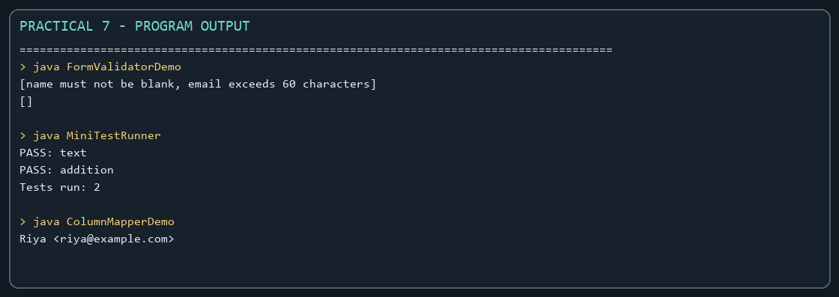
Captured from the compiled practical programs.

